**DOCUMENTATION OF DATA ANAYLSIS**

*A Comprehensive Analysis of Indian’s*

*Agriculture_Crop_Production_Analysis*

*(1997~2021)*

**COMPLETED BY :**

**N.DINESH**

**S.PRAVEEN KUMAR**

**K.RANJITH KUMAR**

**S.PRABHAKARAN**

**S.ARUL DANIEL**

**INDIAN’S_AGRICULTURE_CROP**

**PRODUCTION_ANALYSIS**

**(1997~2021)**

This report delves into the captivating realm of India's agricultural cultivation, providing a comprehensive visual exploration of key aspects and trends in the agricultural sector. Through the visual representations, readers can gain valuable insights into crop production, seasonal variations, regional distribution, and overall production trends. These visualizations enable intuitive analysis, allowing stakeholders to uncover patterns, identify areas of growth or concern, and make data-driven decisions.

This report not only presents the data in a visually appealing manner but also provides an interactive experience for readers to explore the intricacies of India's agricultural cultivation.

**EMPATHY MAP**

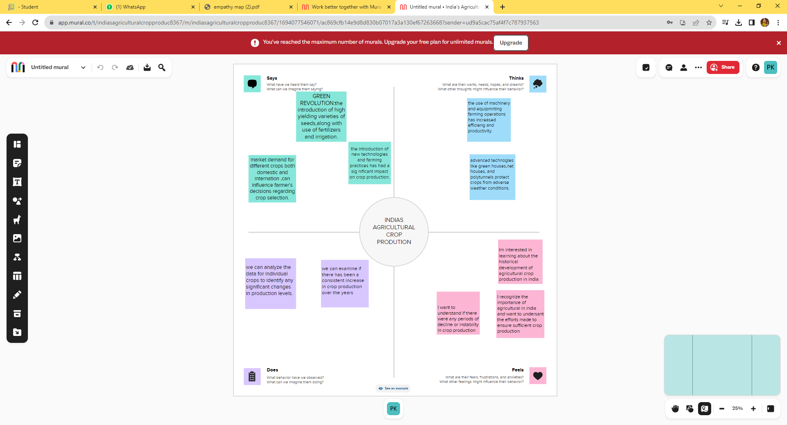

**IDEATION & BRAINSTORMING MAP**

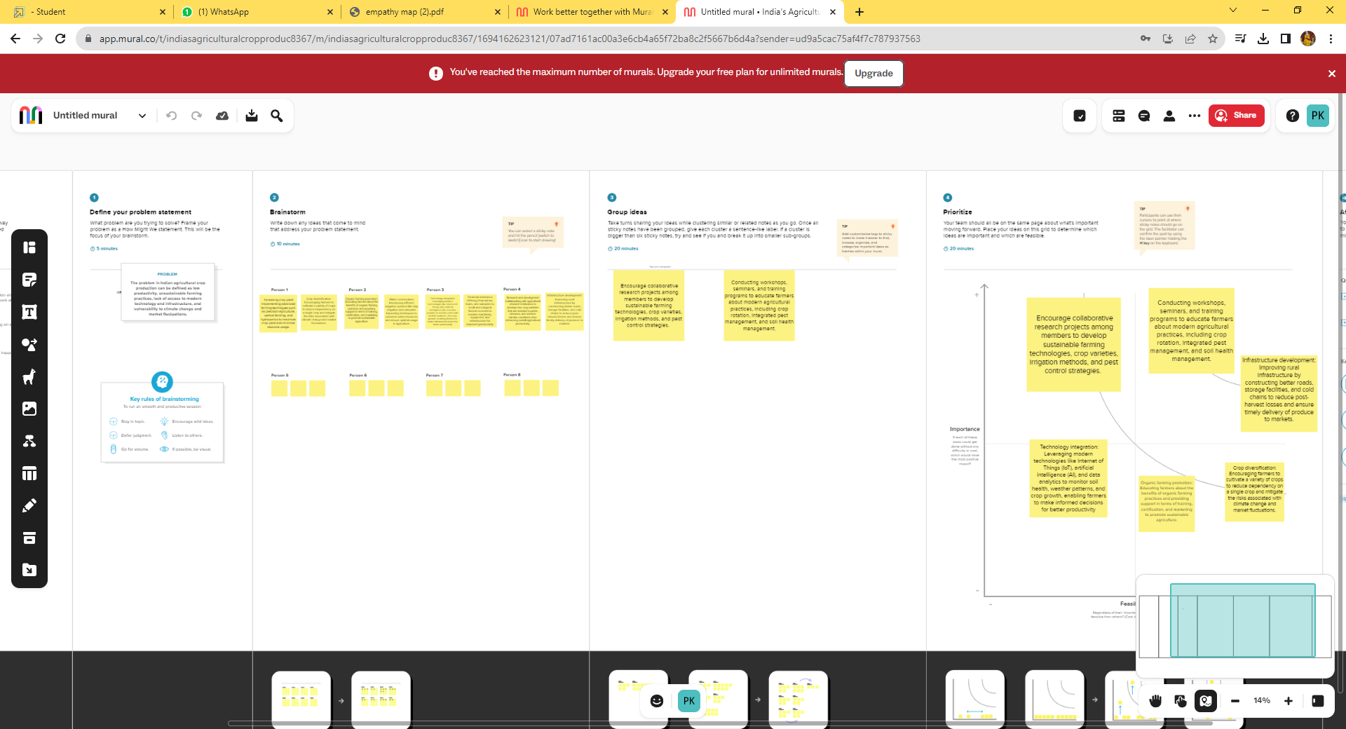

**PROJECT FLOW**

* **Define Problem / Problem Understanding**
* Specify the business problem
* Business requirements
* Literature Survey
* **Data Collection & Extraction**
* Collect the dataset
* Connect Dataset with Tableau
* **Data Preparation**
  + Prepare the Data for Visualization
* **Data Visualizations**
* No of Unique Visualizations
* **Dashboard**
* Responsive and Design of Dashboard
* **Story**
* No of Scenes of Story
* **Performance Testing**
* Utilization of Data Filters
* No of Visualizations/ Graphs
* **Publishing**
* Publishing Dashboard & Story to Tableau Public
* **Project Demonstration & Documentation**
* Record explanation Video for project end to end solution
* Project Documentation-Step by step project development producer

**MILESTONE 1**

**DATA COLLECTION & EXTRACTION FROM DATABASE**

* + **ACTIVITY 1 :**

***DOWNLODING THE DATA SET :***

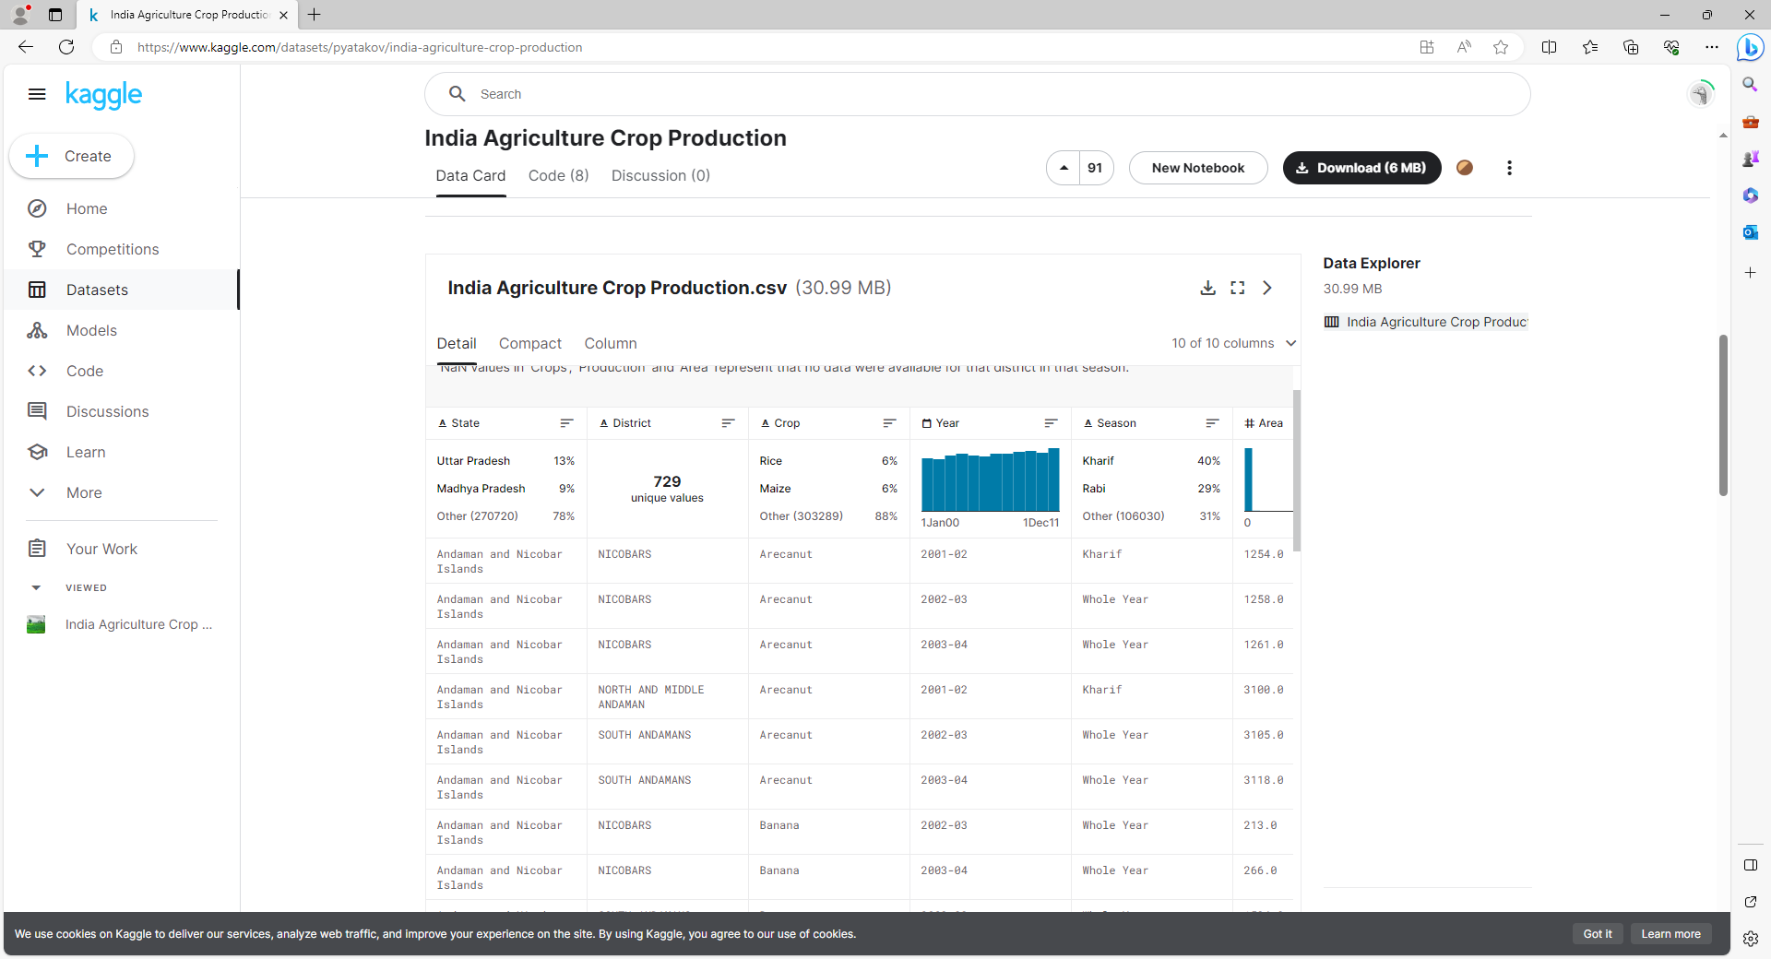

In this activity we can able to understand to create the data which contains all the Meta information regarding the columns described in the CSV files i.e.:

1. State : Name of the state
2. District : Name of the district in a state
3. Crop : In which state can produce the crop production
4. Season : How many season will Indians crop production
5. Area : How many area’s with producing the land

**ACTIVITY 2 :**

***Connect DB with tableau :***

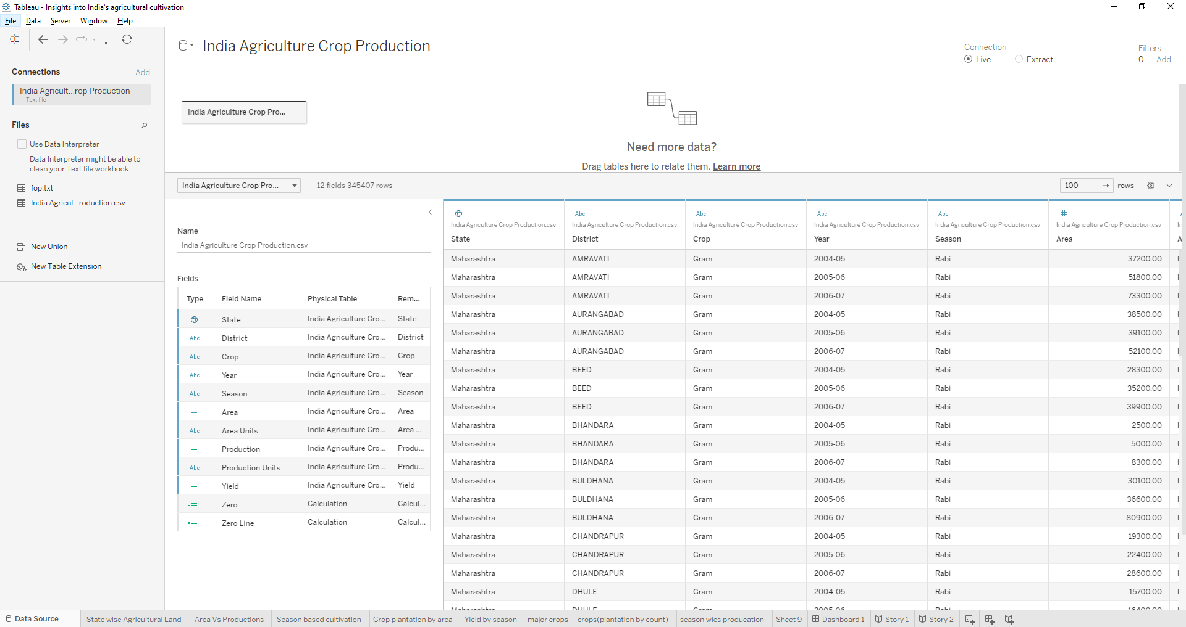

In this activity we can able to understand, how to connect the data base with tableau.

**MILESTONE 2**

#### Data Preparation:

* + **ACTIVITY 1 :**

***Prepare the Data for Visualization:***

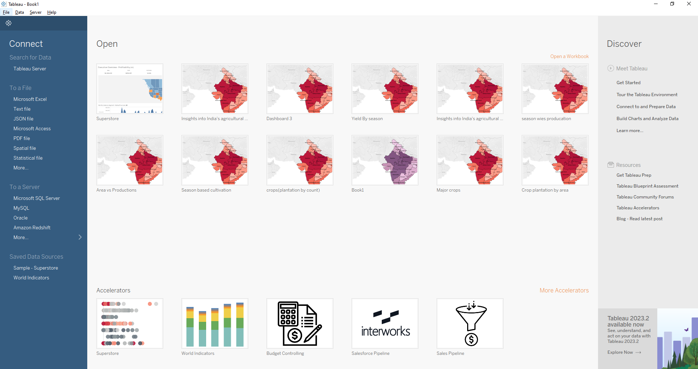



In this activity we can able to understand, how to prepare the data for visualization in tableau.

**MILESTONE 3**

***Data for Visualization:***

* + **ACTIVITY 1 :**

***No of Unique Visualizations***

* + **ACTIVITY 1 .1 :**

**Statewise Agricultural Land**

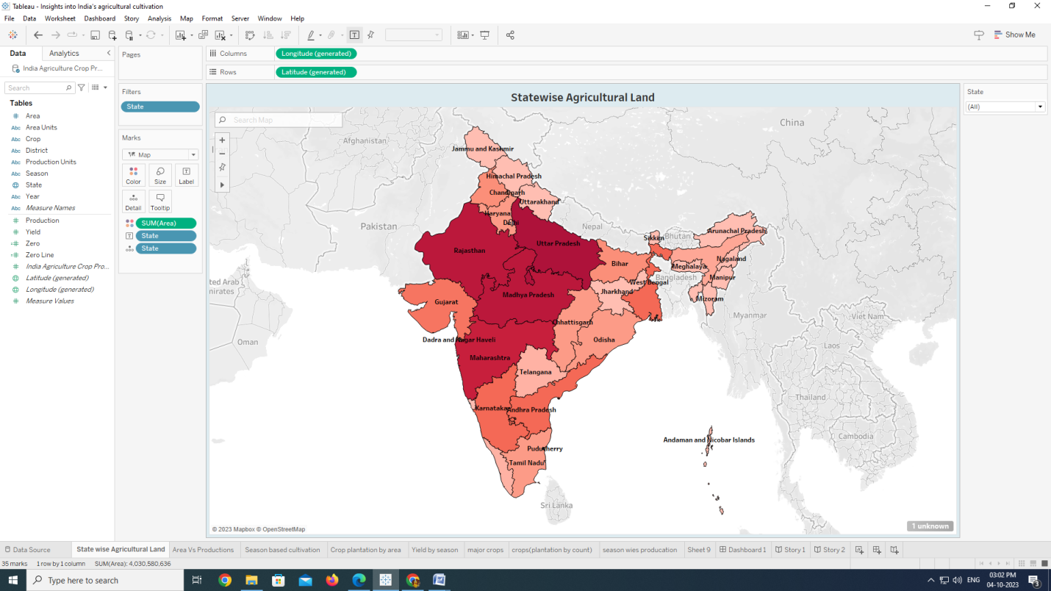

* + **ACTIVITY 1 .2:**

**Area Vs Production**

* + **ACTIVITY 1 .2:**

**Area Vs Production**

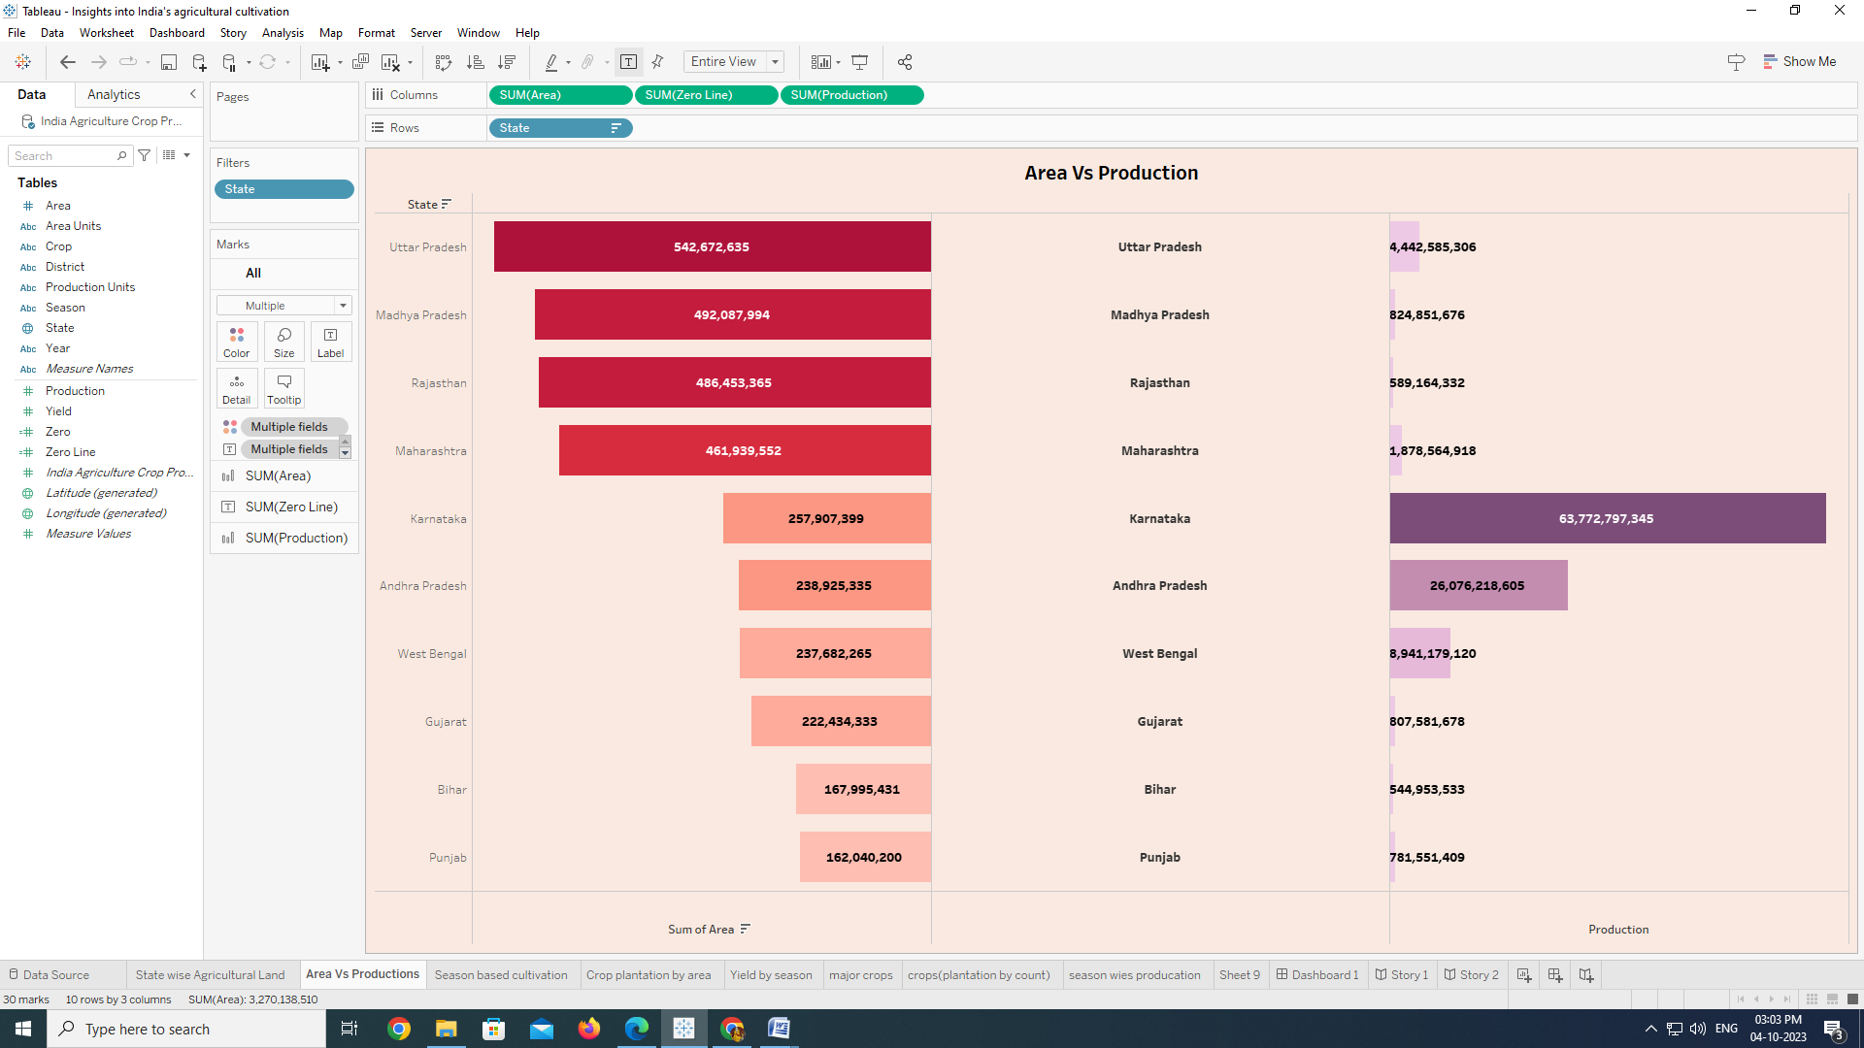

In this activity we can able to understand, how to create the horizontal bars, where we can able to understand the assets of the area production.

* + **ACTIVITY 1 .3:**

**Season based Cultivation**

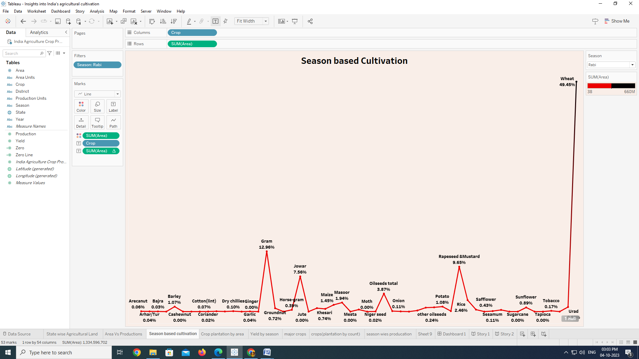

In this activity we can able to understand, how to create the line chart, where we can able to understand the top season according to the state based on the producing.

* + **ACTIVITY 1 .4:**

**Top Crop Plantation By Area**

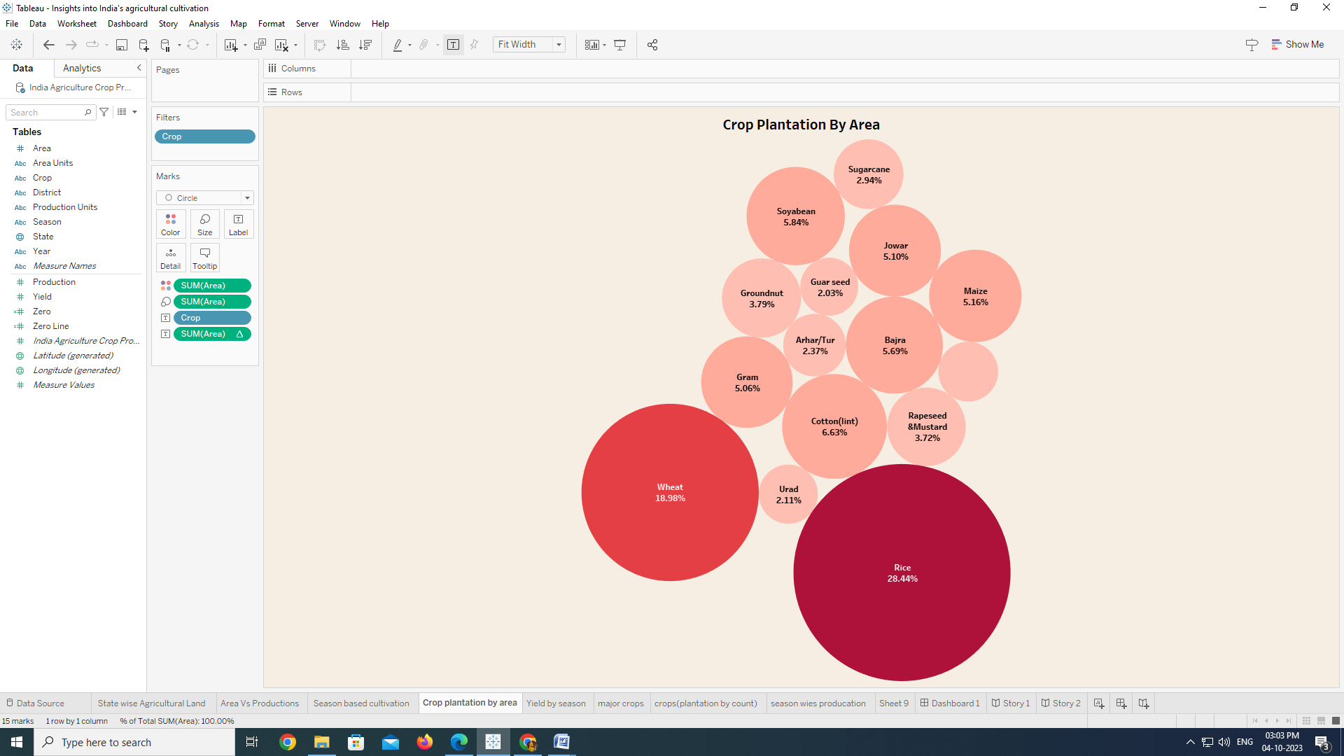

In this activity we can able to understand, how to create the packed bubbles in chart, where we can able to understand the top crop plantation with assets proportion.

* + **ACTIVITY 1 .5:**

**Yield By Season**

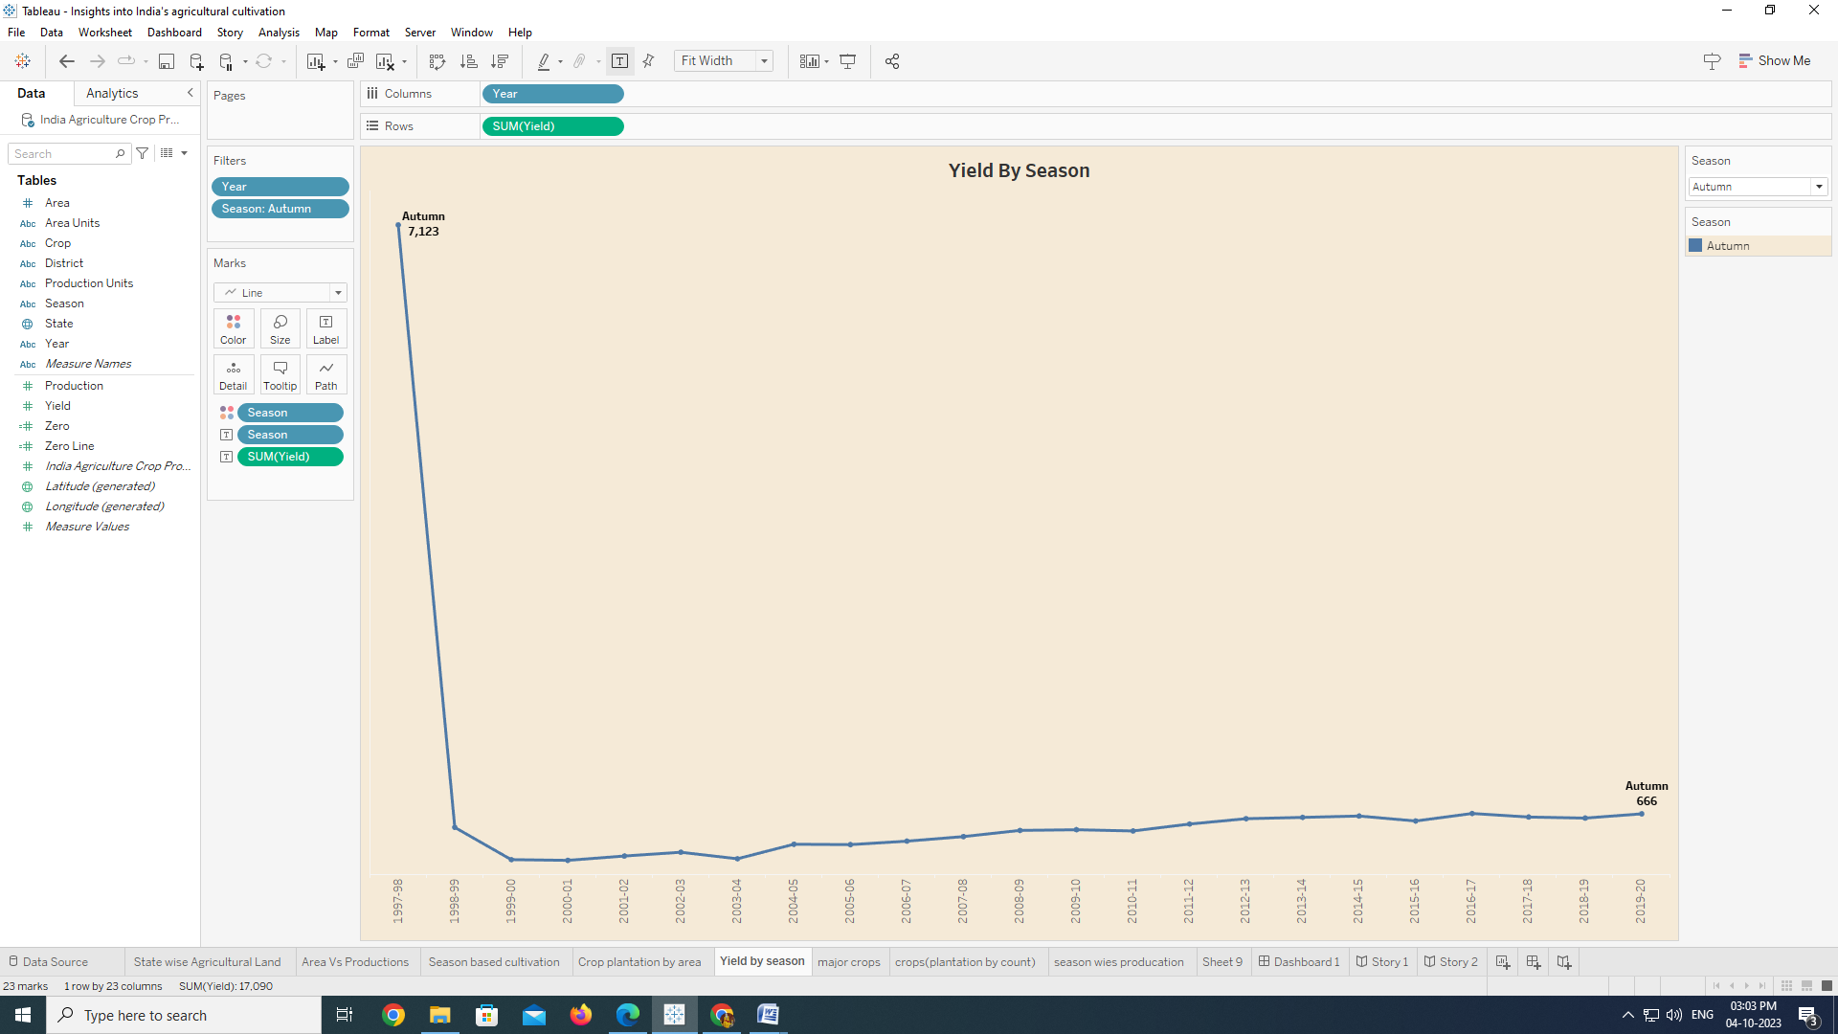

In this activity we can able to understand, how to create the chart line by season, where we can able to understand the top season with assets proportion.

* + **ACTIVITY 1 .6:**

**Top Major Crops :**

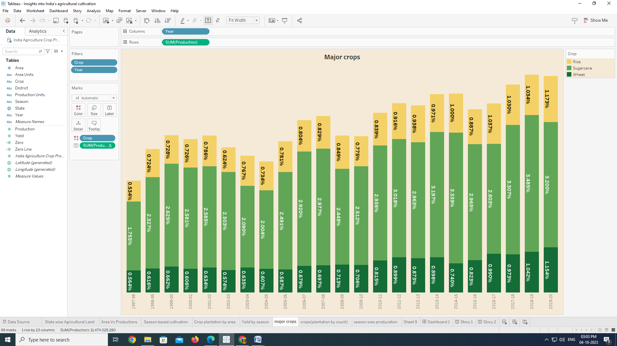

In this activity we can able to understand, how to create the stacked bars, where we can able to understand the top area percentage with assets proportion.

* + **ACTIVITY 1 .7:**

**Crops (plantation by count)**

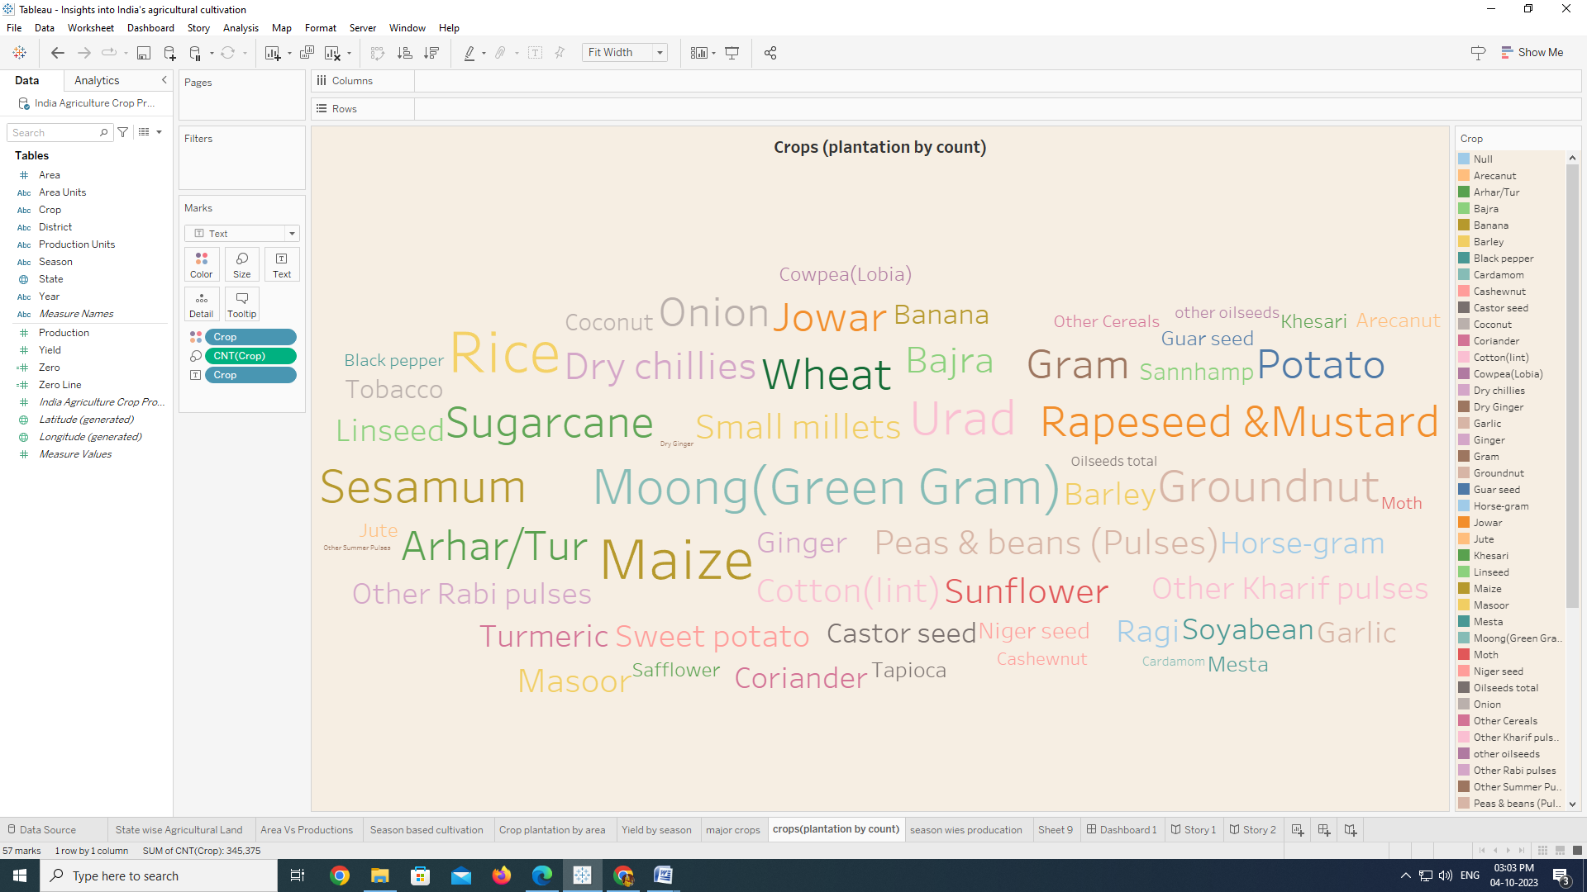

In this activity we can able to understand, how to create the word cloud, where we can able to understand the assets of the crop plantation.

* + **ACTIVITY 1 .8:**

**Season wies production**

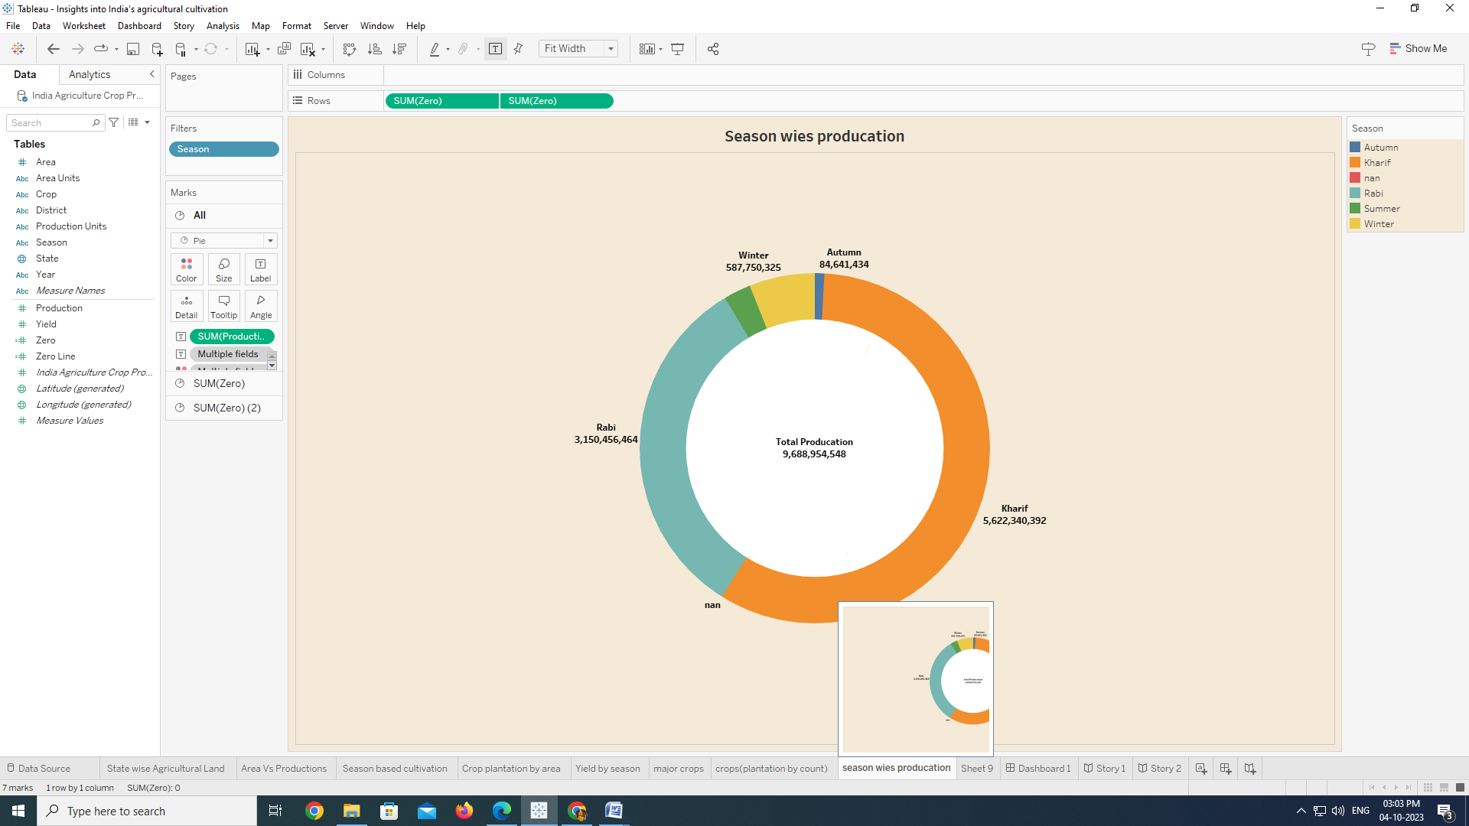

In this activity we can able to understand, how to create the pie/dough-nut chart, where we can able to understand the top 10 states with assets proportion

## Dashboard

## Screenshot (10).png

In this activity we can able to understand, how to create the responsive and the design of dashboard. In this dashboard we can able to analysis the financial of the banks.

# MILESTONE: 5

## Story:1

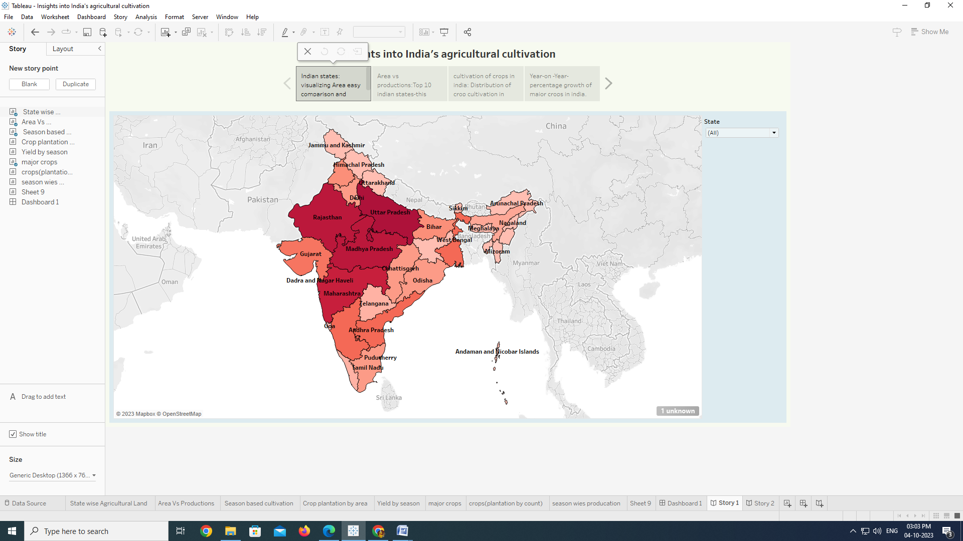

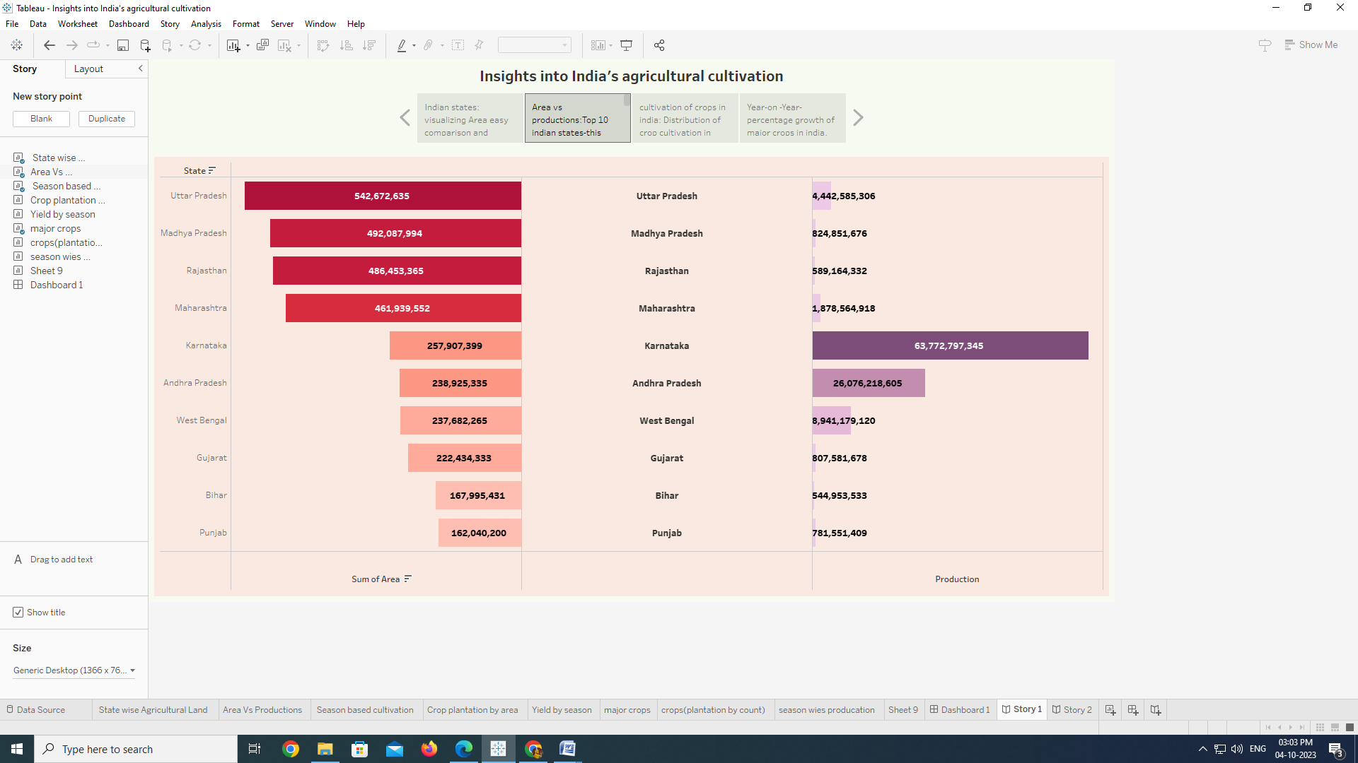

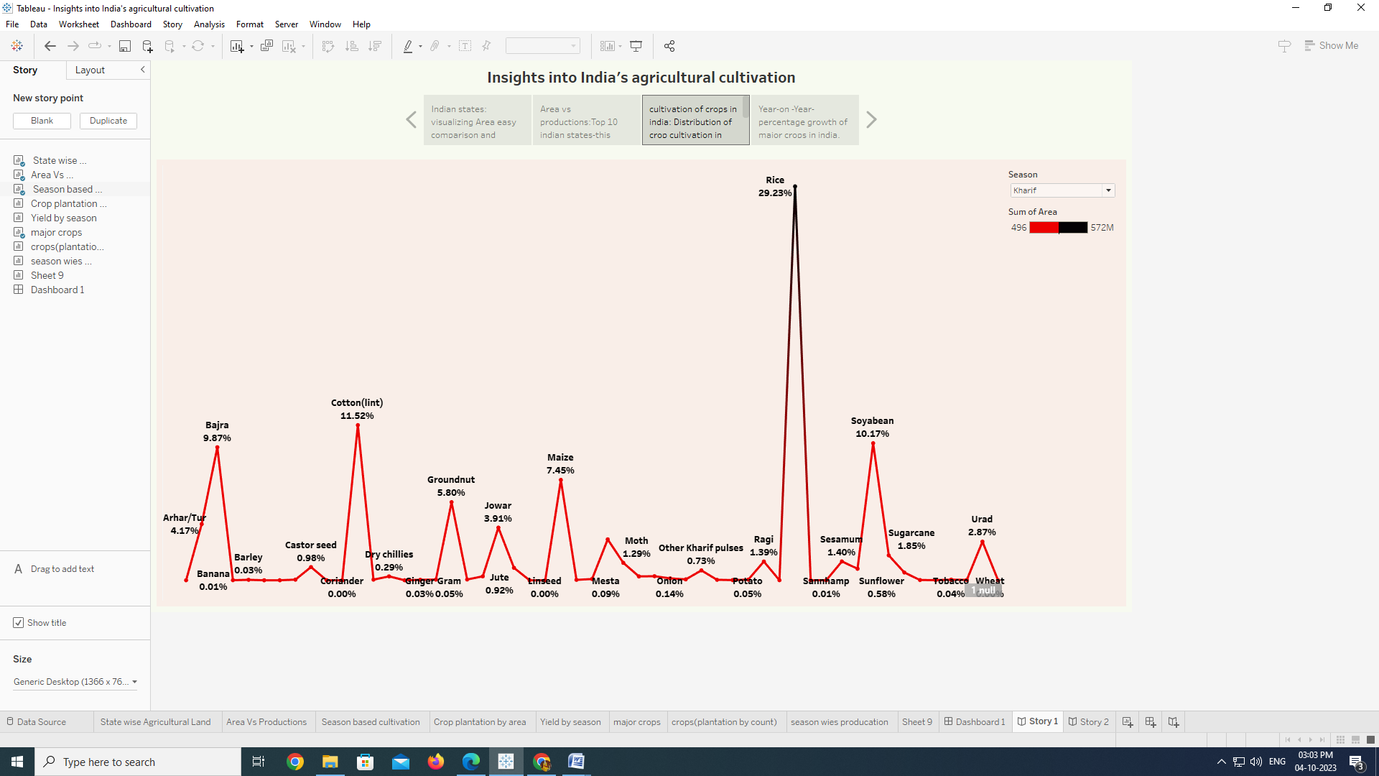

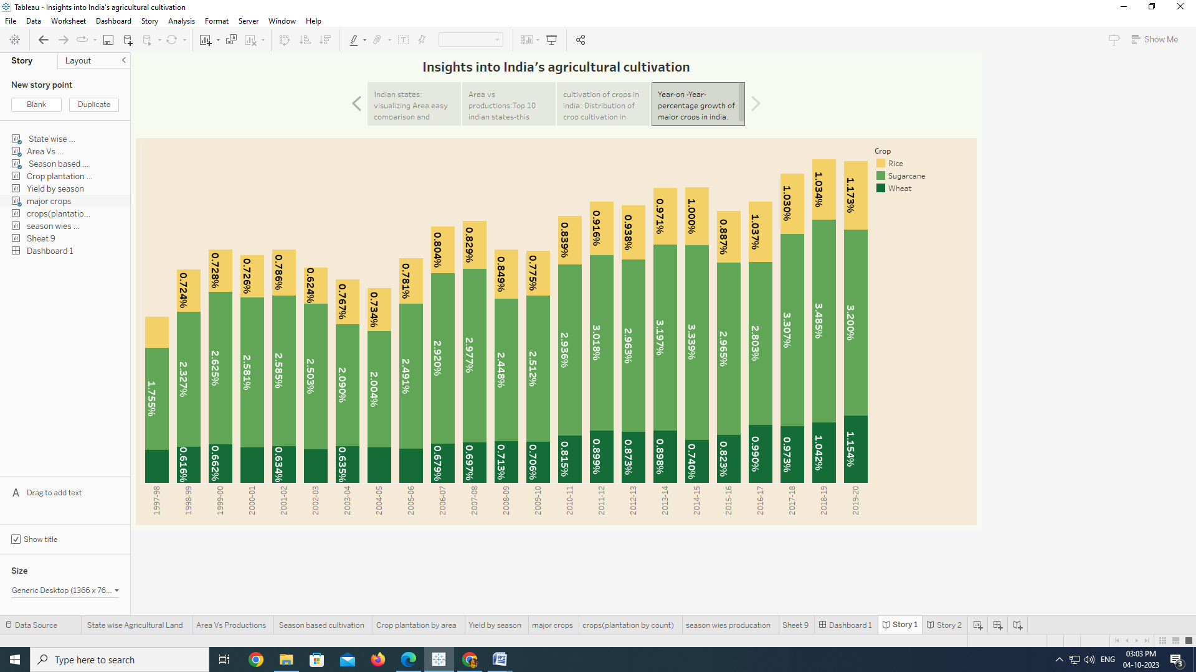story:2

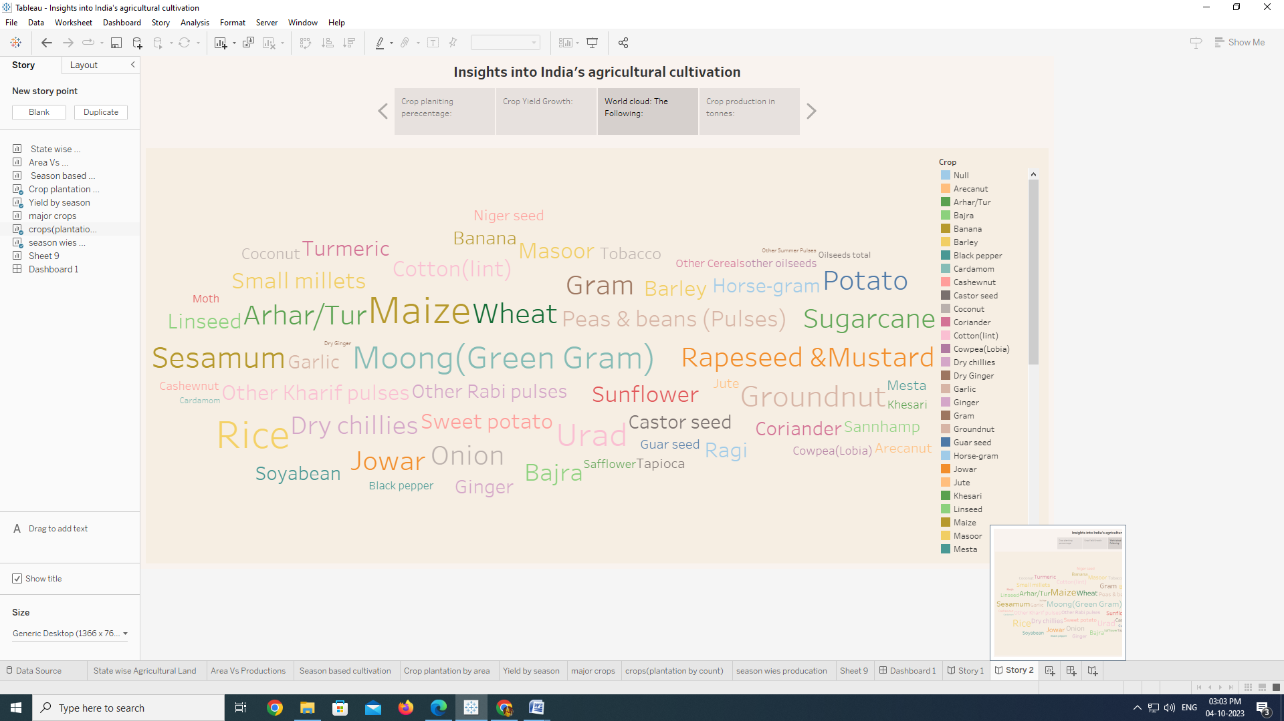

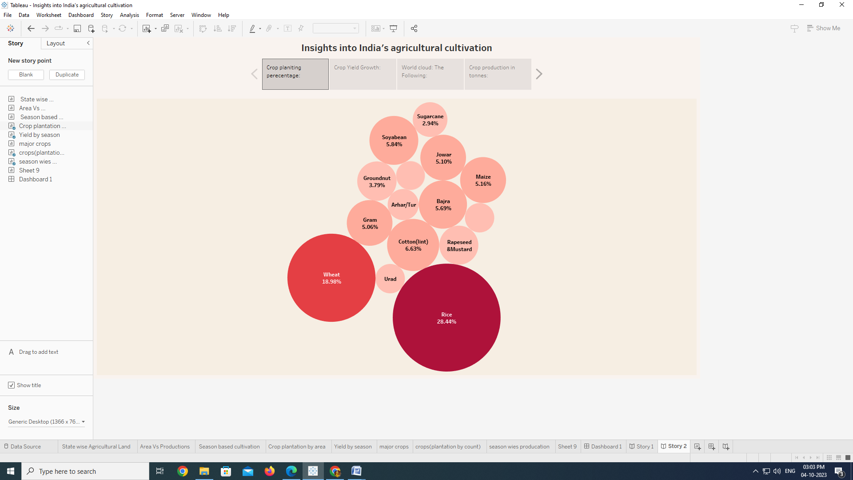

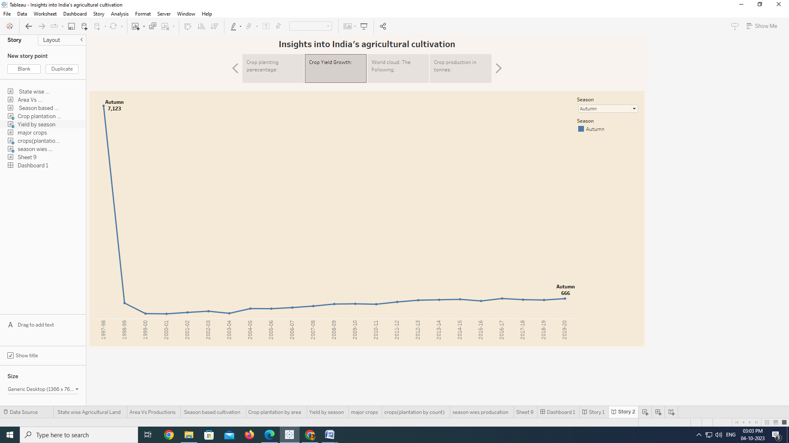

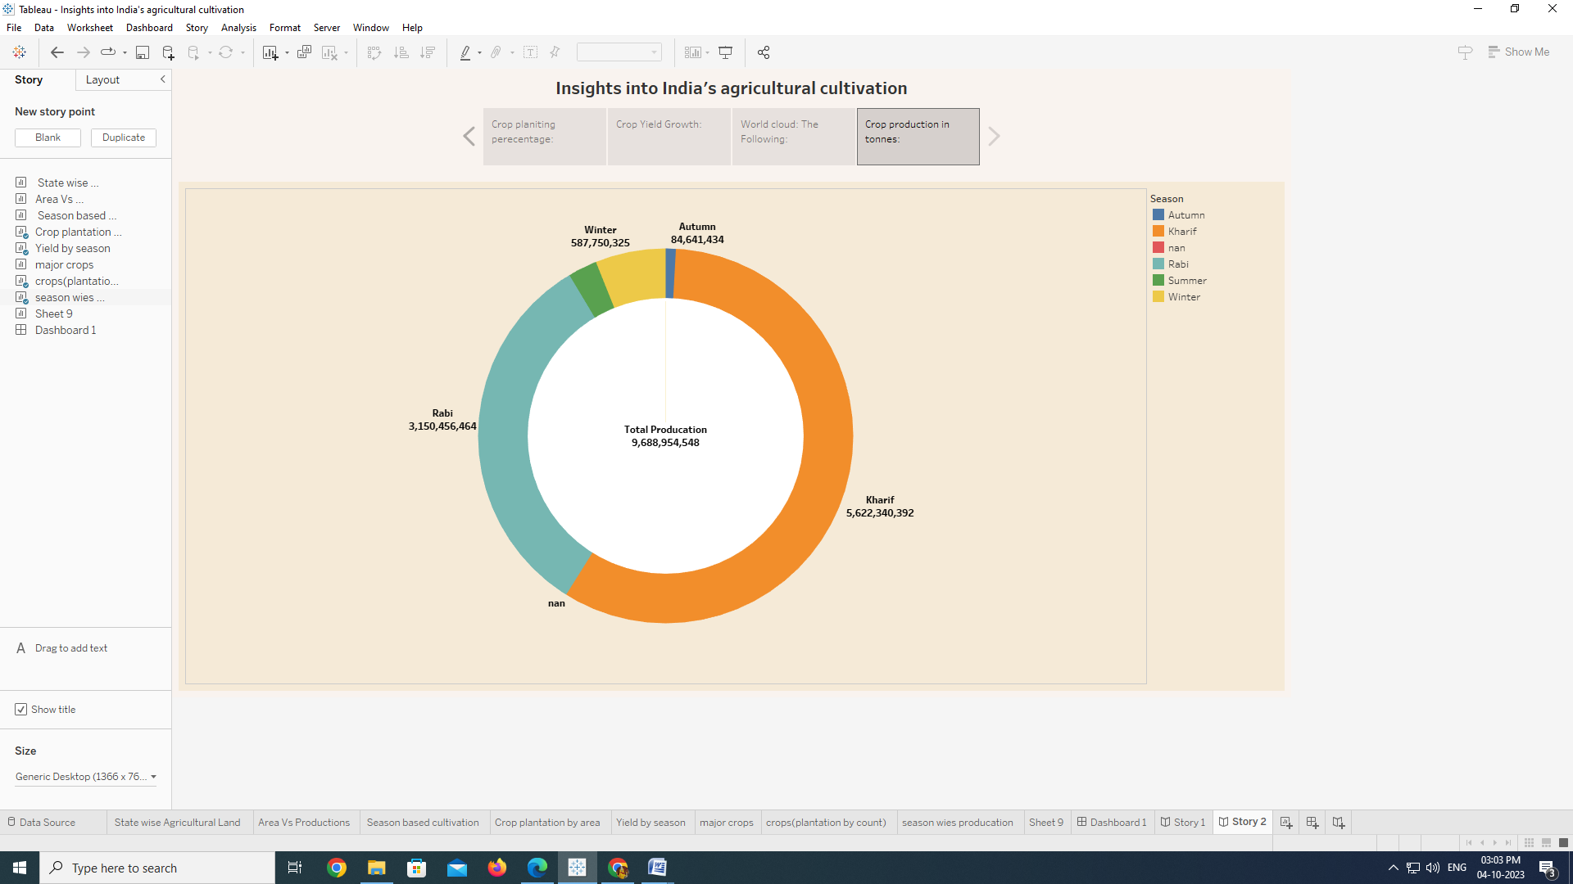

this activity we can able to understand, how to create the story board.

**ADVANTAGES AND DISADVANTAGES:**

Advantages:

* + Tableau can handle millions of rows of data with ease.
  + Therefore, it’s technology is there to support complex computations, data blending and dash boarding for the purpose of creating beautiful visualizations that deliver insights that cannot easily be derived from staring at a spreadsheet.
  + Different types of visualization can be created with a large amount of data without impacting the performance of the dashboards.

Disadvantages:

* Tableau does not provide the feature of automatic refreshing of the reports with the help of scheduling.
* There is no option of scheduling in Tableau.

### Conclusion

In this project, we learnt different ways to create calculated fields in Tableau as well as different types of calculated fields and plotting the appropriate graph. Our data sources will not have all the possible fields we want to use in our analysis. Calculated fields allow us to derive values based on logic and expressions; they ultimately add more flexibility and drive more insights into our Tableau dashboards.

### 

### Future Scope:

A tableau is a powerful tool for data visualization and analysis. Data analysts can use the tool to create valuable reports that help them make intelligent decisions quickly and easily.